1. Launch Selenium IDE.

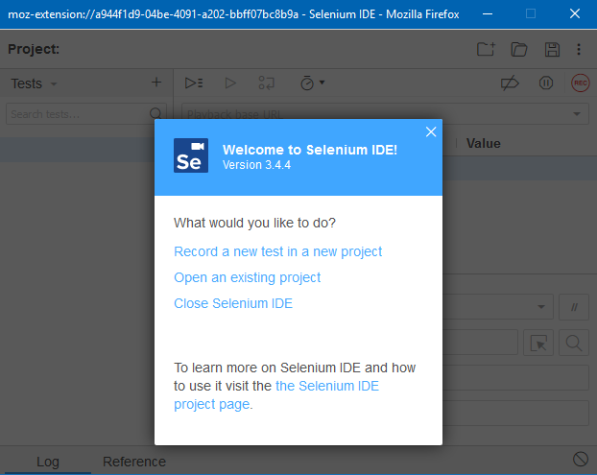

Picture 1

1. Select “*Record a new test in a new project*” -> “*PROJECT NAME*” write the name of the project and press “OK”. Specify the base URL of our project -> *Start Recording*.

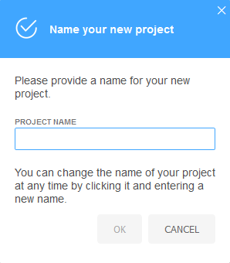

Picture 2

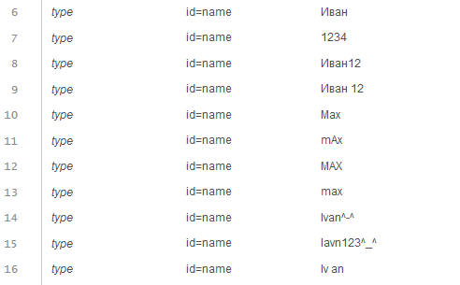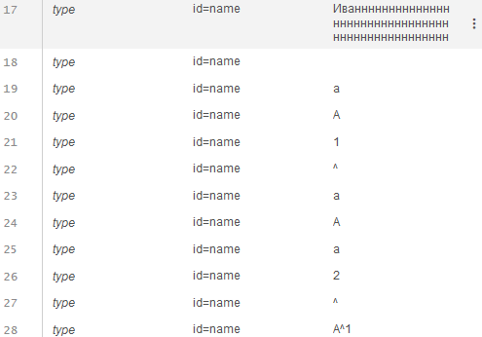

Picture 3

Checking for valid input

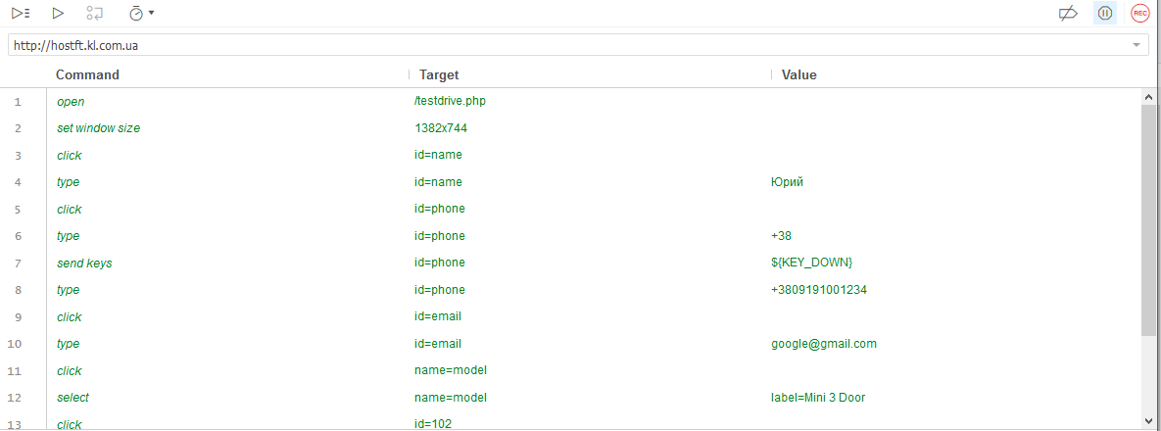

Picture 4

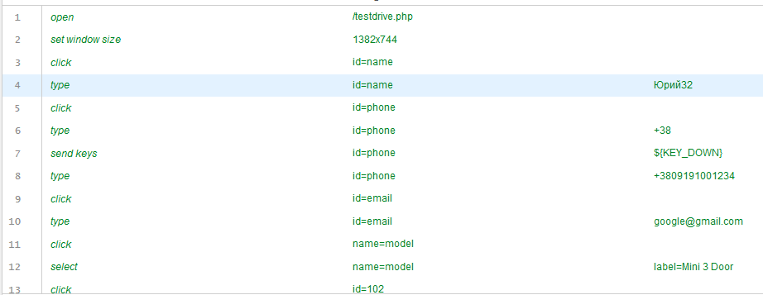

Picture 5

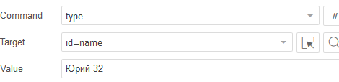

Picture 6

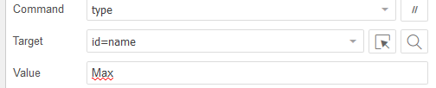

Picture 7

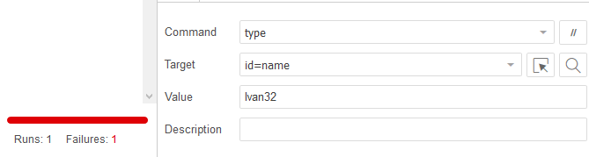

Picture 8



Picture 9

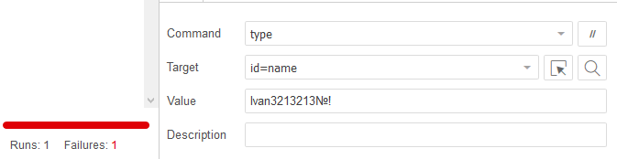

Picture 10

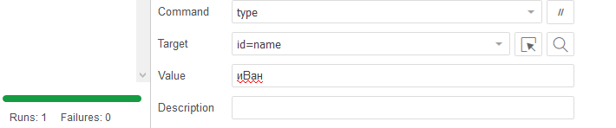

Picture 11

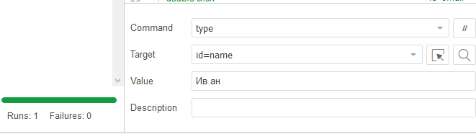

Picture 12

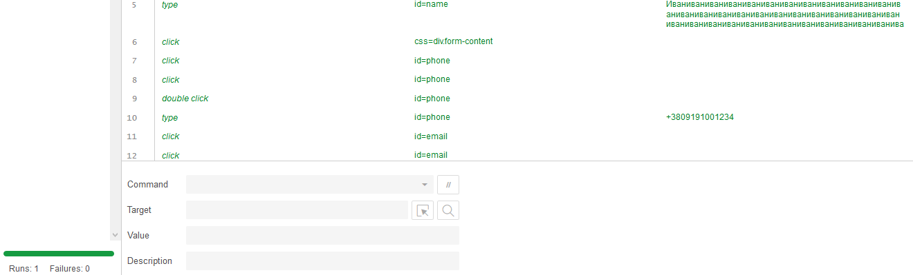

Picture 13

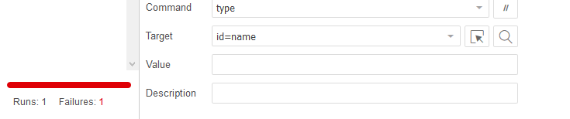

Picture 14

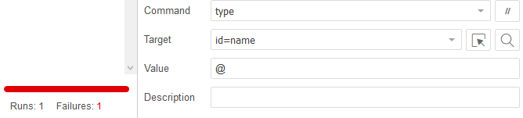

Picture 15

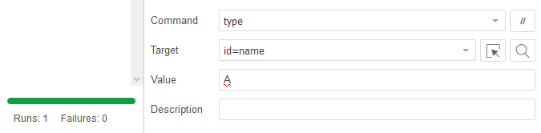

Picture 16

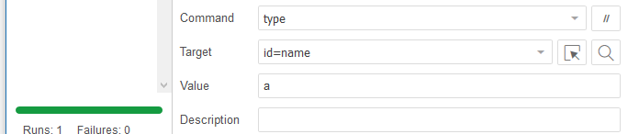

Picture **17**

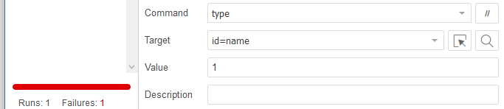

Picture 18

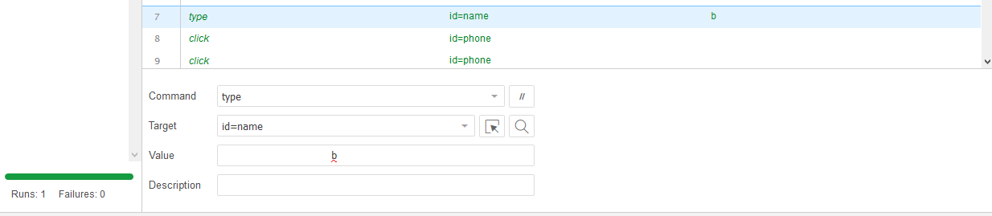

Picture 19

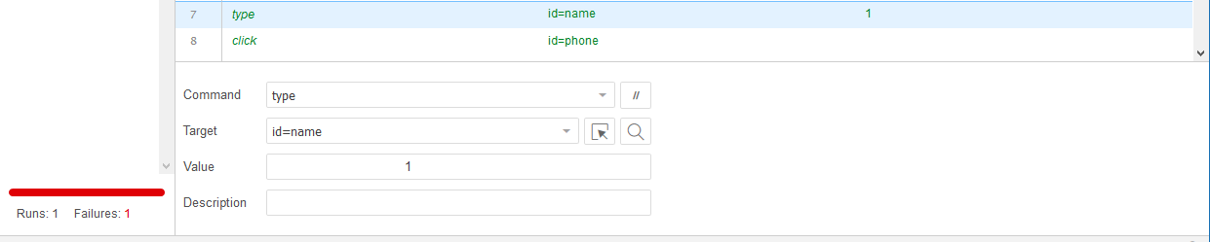

Picture 20

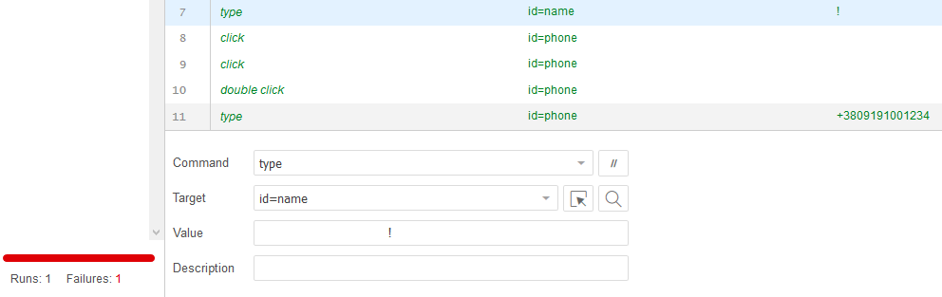

Picture 21

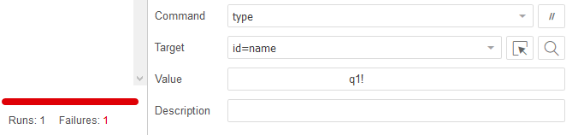

Picture 22

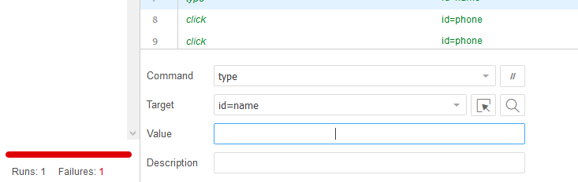

Picture 23